TEAM5OARS

SE Team Project with Line Numbers
TEXTUAL ANALYSIS for
Requirements Workflow
UML USE CASE DIAGRAM

Version 1.0

# of Actors: 6

Table of Actors:

Actor # | Actor Role
1 | Tenant
2 | Assistant
3 | Manager
4 | Supervisor
5 | Staff Employees
6 | Visitor

# of UCs: 17

Table of UCs:

UC # | UC Name
1 | UCLookUp
2 | UCPayRent
3 | UCEnterComplaint
4 | UCEnterTestimonial
5 | UCHandleNewRentals
6 | UCListOfAPT_NO
7 | UCListOfAUTO_MAKE
8 | UCListOfLease
9 | UCListOfRent
10 | UCPendingComplaints
11 | UCStaffRentalSummary
12 | UCStaffAPTDetails
13 | UCStaffAPTDetails
14 | UCListOfTenant
15 | UCAPTPaymentList
16 | UCSearchTestimonials
17 | UCSearchTestimonials

TEAM5OARS (Online Apartment Rental System) is a web site that manages an apartment complex data (all web pages must have the text TEAM5OARS APARTMENTS):
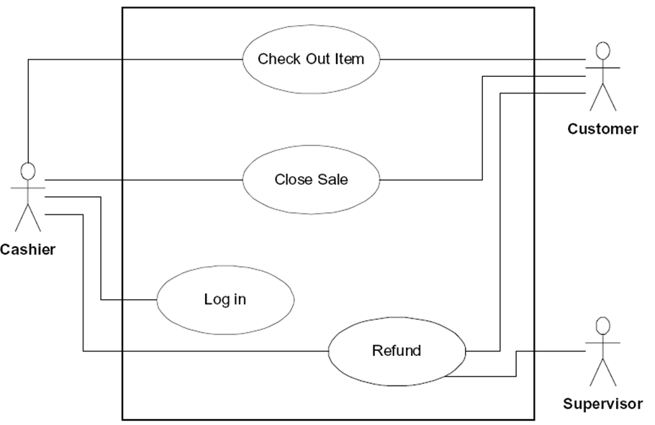
A1: Tenant
A2: Assistant
A3: Manager
A4: Supervisor
A5: Staff Employees
A6: Visitor
The TEAM5OARS web site should be designed using these principles:
Text must be grammatically sound and spelled correctly. Poor spelling loses credibility points straight away. Ensure that there is plenty of well laid out textual content on the site to attract search engines as well as to inform prospective clients.
Use keyword and key phrase rich text; that is, utilize copy that includes common phrases that people would enter into search engines when performing a query.
TEAM5OARS needs to be viewable from at least Chrome and Firefox browsers.
Images are a wonderful medium to assist in the online application, especially useful to those clients with poor literacy levels or who are in a rush, as we all seem to be these days. But remember, while a picture may be worth a thousand words in the offline world, its worth next to nothing when it comes to search engines as spiders do not 'see' pictures.
Image HTML coding should also contain 'alt' tags. This is a textual representation of the image which is useful for the situations where the image doesn't load for some reason. Search engines spiders also latch on to this content, especially if the image is linked to another page. 'alt' text will also pop up when a visitor moves their mouse over the image. Client requires that pictures and videos be used in TEAM5OARS.
TEAM5OARS site navigation should be simple and all the questions a consumer may ask should be answered along the way. Where possible, adhere to the "three click rule" - that is, a visitor should be able to access any information regarding your service within 3 clicks of any other area of your web site.
TEAM5OARS should take advantage of the Javascript and Ajax technologies.
TEAM5OARS implements a live online support chat allowing communication of visitors and tenants with TEAM5OARS Customer Service over the Internet in real time directly from TEAM5OARS web site. No chat information will be stored in the database.
TEAM5OARS web site will have at least the following pages “TEAM5OARS Home” page, “About Us” page, and “Testimonials” page with a search function. Testimonials are stored in the database. The search is done by a stored procedure.

TEAM5OARS must be developed according to the principles and techniques described in COSC 4351. Teams will have 1 TL (Team Leader), 2 DBAs (DataBase Administrator), 1 SQA (Software Quality Assurance), and 2-3 TMs (Team Members).
TEAM5OARS has the following data related to the STAFF (contains data on employees who work at TEAM5OARS: STAFF_NO, unique staff numbers. Values are SA200, SA210, SA220, etc. (unique and increases by 10). FIRST_NAME, first name of the staff employee. LAST_NAME, last name of the staff employee. POSITION, the job title held by the staff employee, the values are “Assistant”, “Manager”, “Supervisor” and “CustomerService”. GENDER, gender of the staff, the values are M (for male) or F (for female). DOB, date of birth of the staff employee. SALARY, the salary of the staff employee. USERNAME, the user name of the staff employee to login to TEAM5OARS. PASSWORD, the password of the staff employee to login to TEAM5OARS.

TEAM5OARS has the following data related to the APARTMENT: APT_NO, the unique apartment number, with values 100, 101, 102 (studio), 103, 104 (one bedroom), 200, 201 ( 2 bedrooms), 202, 203 (three bedrooms). APT_TYPE, type of the apartment. Values are 0,1,2,3. 0 indicates studio apartment; 2 indicates two-bedroom apartment; 3 indicates a three-bedroom apartment. APT_STATUS, rental status of an apartment. Values are V (for vacant) or R (for rented). APT_UTILITY, availability of utilities in an apartment. Values are Y (utilities available) or N (utilities not available). APT_DEPOSIT_AMT, amount required as deposit for the apartment. APT_RENT_AMT, rent for the apartment.
TEAM5OARS has the following data related to the TENANT: TENANT_SS, the social security number of the tenant. TENANT_NAME, the full name of the tenant. TENANT_DOB, the date of birth of the tenant. MARITAL, the marital status of the tenant. Values are M (for married) or S (for single). WORK_PHONE, phone number of the work place. HOME_PHONE, phone number of the tenant apartment (home). EMPLOYER, the employer name of the tenant. GENDER, gender of the tenant, the values are M (for male) or F (for female). USERNAME, the user name of the tenant to login to TEAM5OARS. PASSWORD, the password of the tenant to login to TEAM5OARS.

TEAM5OARS has the following data related to the TENANT_AUTO: LICENSE_NO, the plate number of the automobile. AUTO_MAKE, the manufacturer of the automobile. AUTO_MODEL, the model name of the automobile. AUTO_YEAR, the year of the model. AUTO_COLOR, the color of the automobile.

TEAM5OARS has the following data related to the TENANT_FAMILY (contains data on the other person details who are sharing the apartment with the tenant): FAMILY_SS, the social security number of the other person. NAME, the full name of the person. SPOUSE, identification of whether the person is a spouse of the tenant. The values are Y (yes) or N (no). CHILD, identification of whether the person is a child of the tenant. The values are Y (yes) or N (no). DIVORCED, identification of whether the person is divorced. The values are Y (yes) or N (no). SINGLE, the identification of whether the person is single or married. The values are Y (yes) or N (no). GENDER, gender of the person. The values are M (for male) or F (for female). DOB, the date of birth of the person.

TEAM5OARS has the following data related to the RENTAL (contains data on rentals of various apartments): RENTAL_NO, unique rental number, values are 100101, 100102, etc., incrementing by one. RENTAL_DATE, the date rental contract was signed. RENTAL_STATUS, status of the rental, values are S (rental signed but not occupied) or O (for apartment occupancy). CANCEL_DATE, date the rental agreement can be cancelled. LEASE_TYPE, type of lease, values are One (for one year lease) or Six (for six months lease). LEASE_START, date the current lease starts. LEASE_END, date the current lease ends. RENEWAL_DATE, date by which the lease should be renewed.

TEAM5OARS has the following data related to the RENTAL_INVOICE (contains data on payment of rent by tenants): INVOICE_NO, unique invoice number, values are 1000, 1001, etc., increasing by one. INVOICE_DATE, date on which invoice generated. INVOICE_DUE, amount due for the rent. CC_NO, credit card number for payment. CC_TYPE, type of credit card used toward payment. CC_EXP_DATE, date of expiration on the credit card. CC_AMT, amount charged on the credit card.

TEAM5OARS has the following data related to the COMPLAINTS (contains data on complaints filed by tenants as well as staff employees regarding apartments): COMPLAINT_NO, unique complaint number, values 10010, 10011, etc., increasing by one. COMPLAINT_DATE, date the complaint is filed. RENTAL_COMPLAINT, description of the complaint regarding the rental. APT_COMPLAINT, description of the complaint regarding the apartment. STATUS, status of the complaint, values are F (fixed the complaint), P (complaint pending), or NULL (complaint situation not determined).

Testimonials can only be entered by tenants but can be read by anybody (including the visitors of the TEAM5OARS).
TEAM5OARS has the following data related to the TESTIMONIALS (contains data on testimonials filed by tenants): TESTIMONIAL_ID, testimonial id, values 100, 101, etc., increasing by one. TESTIMONIAL_DATE, date when the testimonial was entered, TESTIMONIAL_CONTENT, the content of the testimonial. TESTIMONIAL_CONTENT can be searched by using keywords.

TEAM5OARS provides the following functionality:
Tenant (after login display their name and position on the web page) should be able to:
After Login, tenant information must be displayed, call that web page TenantIntro.
TenantIntro (home page for tenant) must display:
- the following TENANT’s information TENANT_SS, TENANT_NAME, TENANT_DOB, MARITAL, WORK_PHONE, HOME_PHONE, EMPLOYER, GENDER,

- the following TENANT_AUTO’s information LICENSE_NO, AUTO_MAKE, AUTO_MODEL, AUTO_YEAR, AUTO_COLOR,

- the following TENANT_FAMILY information (if applicable) FAMILY_SS, NAME, SPOUSE, CHILD, DIVORCED, SINGLE, GENDER, DOB.
UC1: UCLookUp
- Look up (view) their rental agreement (TEAM5OARS must ensure that the RENTAL_ID belongs to this tenant), with the following information Rental Number, Rental Date, Apartment Number, Apartment Type, Apartment Deposit ($), Lease Type (two radio buttons labelled Six Months and One Year, only one selected), Tenant SS#, Tenant Name, Tenant Work Number, Tenant Date of Birth
UC2: UCPayRent
- Pay the rent. TEAM5OARS (PayRent web page) Input Form Pay Rent will display the following information Rental Number, and Credit Card Details Card Type (three radio buttons labelled Visa, MasterCard, Discover, only one selected), Card Number, Expiration Date, Amount Charged.
The Apartment Rental Rates with two columns Type (Studio, One Bedroom, Two Bedrooms, and Three Bedrooms) and Amount ($300, $400, $500, and $700) must be present somewhere on the page.
Two buttons Submit Payment and Clear should allow the tenant to handle payment of the rent.
The Output Report Rent Receipt will display the text “Rent Receipt”, underneath “Please print this receipt for your records.”, the Tenant Name, Tenant Social Security No, Rental Number, Apartment Number, Invoice Number, Invoice Date, Invoice (Rent) Amount Paid.
UC3: UCEnterComplaint
- Enter a complaint
UC4: UCEnterTestimonial
- Enter a testimonial
Assistant (after login display their name and position on the web page) should be able to:
UC5: UCHandleNewRentals
- handle new rentals (TEAM5OARS (CreateRental web page)
The Apartment Available List with four columns, a radio button that allows choosing an apartment, Apt No, Apartment Type, Deposit Amount must be present somewhere on the page, to allow the assistant to choose an apartment.
The Apartment Rental Rates with two columns and Amount must be present somewhere on the page.

Input Form Create Rental will display the following information Apartment Number - auto populated (selected from the Apartment Available List), Apartment Type - auto populated (selected from the Apartment Available List), Apartment Deposit - auto populated (selected from the Apartment Available List), Lease Type (two input radio buttons), Tennant SS# input text box, Tenant Name input text box, Tenant Work Phone input text box, Tenant Date of Birth input text box.
One button Create Rental should allow the assistant to handle creating a rental contract.
The Output Report Rental Confirmation Details will display the text “Rental Confirmation Details”, the Rental Number output text box, Rental Date output text box, Rent Deposit output text box, the text “Please Pay Rental Deposit Immediately.”, the text “Thank you.” underneath.

Manager (after login display their name and position on the web page) should be able to request the:
UC6: UCListOfAPT_NO
- List of APT_NO for each apartment that is currently vacant.
UC7: UCListOfAUTO_MAKE
- For each AUTO_MAKE, list the number (count) for each make.
UC8: UCListOfLease
- List the length of the lease for each rental.
UC9: UCListOfRent
- List the amount of rent collected per month if all apartments are rented (and the tenants pay their rent).

Supervisor (after login display their name and position on the web page) should be able to request the:
UC10: UCPendingComplaints
- Pending Apartment Complaints, Complaint #, Apartment #, Apartment Type, Description.
UC11: UCStaffRentalSummary
- Staff Rental Summary, Staff Name, Position, Number of Rentals.
UC12: UCStaffAPTDetails
- Staff Apartment Details, FirstName LastName, Position, and a list of Apartment #.
UC13: UCUpdate
- Update the status of Pending Complaints to Fixed.

All staff employees (Assistant, Manager, Supervisor, and Customer Service) should be able to request:
UC14: UCListOfTenant
- Tenant List, text “Tenant List”, Social Security column, Name column, and Apartment column.
UC15: UCAPTPaymentList
- Apartment (input box) Payment List, text “Payment List”, then for the Apartment output text box and With Rental No output text box the list of Invoice#, Invoice Date, and Payment Type.
UC16: UCSearchTestimonials
- Search testimonials all or by keyword.

Visitors should ONLY be able to:
- Search testimonials all or by keyword.

At the Acceptance Testing, a scenario of usage of the TEAM5OARS will be given to you. Data about APARTMENT, STAFF, etc. will be given to the DBAs for your TEAM5OARS.
The client desires that TEAM5OARS be designed and implemented using OO paradigm. Formal Analysis, SRS (Software Requirements Specification) document needs to be signed by the TEAM5OARS and the client BEFORE any design is started. A SPMP (Software Project Management Plan) document needs to be delivered before the actual development is started.

A prototype is highly desirable. Graphical User Interfaces, Web Site Design, each Page Design can expedite the development process.

An MVC (3 tier architecture) is required.
NOTE: This requirements document “SE Team Project with Line Numbers.doc” might go through revisions based on your questions. There might be missing requirements; there might be unclear requirements, or conflicting requirements. I can take 5 minutes each class to answer possible questions.

Controller
UC1: UCLookUp

UC 1

UC2

UC3

UC4

UC2: UCPayRent
A1: Tenant
UC3: UCEnterComplaint
UC4: UCEnterTestimonial

Controller

A2: Assistant

UC 5

UC5: UCHandleNewRentals

Controller

UC 6

UC7

UC8

UC9
UC6: UCListOfAPT_NO

UC7: UCListOfAUTO_MAKE

A3: Manager
UC8: UCListOfLease

UC9: UCListOfRent

Controller

UC10

UC11

UC12

UC13
UC10: UCPendingComplaints

UC11: UCStaffRentalSummary

A4: Supervisor
UC12: UCStaffAPTDetails

UC13: UCUpdate

Controller

UC14

UC15

UC16

UC14: UCListOfTenant

UC15: UCAPTPaymentList

A5: StaffEmployees
UC16: UCSearchTestimonials

Controller

A6: Visitor

UC16

UC16: UCSearchTestimonials
Document Control

Change History

Table 1: TLs entries (assigned work and due dates) before releasing to the team
Revision | Name | Due Date | Description
1.A | Nixon Matthew | 02/06/2016 | Complete Use Case Modeling
1.A | Kaisong Fan | 02/06/2016 | Complete Use Case Modeling
1.A | Keith Russell | 02/06/2016 | Complete Use Case Modeling
1.A | Luis Silva | 02/09/2016 | Review Use Case Modeling and ensure it’s correct

Table 2: Entries when work completed (SVN Commit Comment matches Description)
Revision | Name | Completed Date | Description
1.A |  | XX/XX/XXXX | I …..
1.B |  | XX/XX/XXXX | I …..
1.C |  | XX/XX/XXXX | I …..
1.D |  | XX/XX/XXXX | I …..
1.E |  | XX/XX/XXXX | I …..

Table 3: TL entry for RED DELIVERABLES (SVN Commit Comment matches Description)
Revision | Name | Due Date | Description
2.0 | TL & Name | XX/XX/XXXX | I changed Version to 2.0

Document Storage
This file is stored in SVN at https://svn.cs.uh.edu/svn/cosc4351/team5/TEAM PROJECT DELIVERABLES/SE Team Project with Line Numbers for UML USE CASE DIAGRAM.doc.

PLEASE DO NOT INCLUDE THESE PAGES AS YOUR DELIVERABLES! This is just the template for your use.
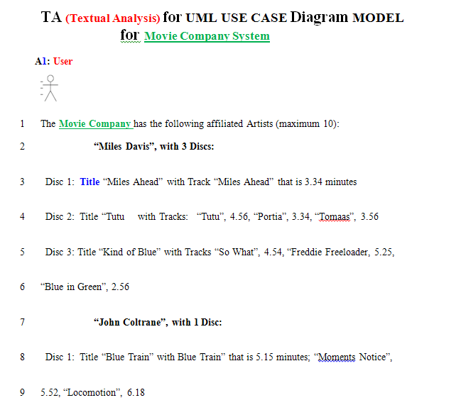
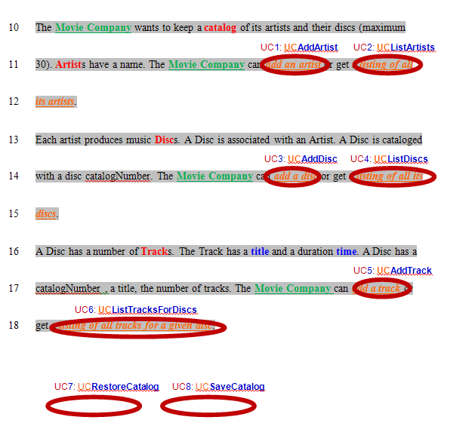

UCAddArtist
UCListArtists
UCAddDisc
UCListDiscs
UCAddTrack
UCListTracksForDisk
Controller

UC 1

UC2

UC3

UC4

UC5

UC6

UC7

UC8

UCRestoreCatalog
UCSaveCatalog
A1: User

UC1 UCAddArtist Description
Name: | UCAddArtist
Actor: | User
Description: | This use case describes the process used by User to Add another Artist
Successful Completion: | User requests Adding Artist by artistName  - Movie Company System checks to see if not already there and there is room in the artists array  - Artist with artistName is added at the end of the artists array and successful message is sent to the User
Alternative: | User requests Adding Artist by artistName  - Movie Company System checks to see if not already in the artists array and there is no room  - If artistName either ALREADY present or NO MORE ROOM MAX_ARTISTS Artist with artistName is NOT added and UNsuccessful message is sent to the User
Pre-Condition: | User requests Add Artist
Post-Condition: | Artist with artistName Added successfully or UNsuccessfully
Assumptions: | None

UC2 UCListArtists Description
Name: | UCListArtists
Actor: | User
Description: | This use case describes the process used by User to List all Artists
Successful Completion: | User requests Listing Artists  - Movie Company System displays all the Artists by traversing the artists array
Alternative:
Pre-Condition: | User requests List Artists
Post-Condition: | Artists displayed
Assumptions: | None

UC3 UCAddDisc Description
Name: | UCAddDisc
Actor: | User
Description: | This use case describes the process used by User to Add another Disc for a particular artistName
Successful Completion: | User requests Adding Disc to artistName  - Movie Company System prompts for discCatalogNumber  - Movie Company System prompts for disc  - Disc discCatalogNumber , disc is Added to the disks array and successful message is sent to the User
Alternative: | User requests Adding Disc to artistName  - Movie Company System prompts for discCatalogNumber  - Movie Company System prompts for disc  - Movie Company System checks to see if not already the disks array and there is room in the disks array  - If disc either ALREADY present or NO MORE ROOM MAX_DISCS Disc disc is NOT added and UNsuccessful message is sent to the User
Pre-Condition: | User requests Add Disc
Post-Condition: | Disc discCatalogNumber, disc Added to the disks array successfully or UNsuccessfully
Assumptions: | None

UC4 UCListDiscs Description
Name: | UCListDiscs
Actor: | User
Description: | This use case describes the process used by User to List all Discs
Successful Completion: | User requests Listing Discs  - Movie Company System displays all the Discs in the disks array, discCatalogNumber, title, artistName
Alternative:
Pre-Condition: | User requests List Discs
Post-Condition: | Discs displayed
Assumptions: | None
UC5 UCAddTrack Description
Name: | UCAddTrack
Actor: | User
Description: | This use case describes the process used by User to Add another Track trackTitle, time for a particular discCatalogNumber
Successful Completion: | User requests Adding Track to Disc discCatalogNumber  - Movie Company System prompts for trackTitle  - Movie Company System prompts for time  - Track trackTitle, time is Added to Disc discCatalogNumber and successful message is sent to the User
Alternative: | User requests Adding Track to Disc discCatalogNumber  - Movie Company System prompts for trackTitle  - Movie Company System prompts for time  - Movie Company System checks to see if not already there and there is room  - If trackTitle either ALREADY present or NO MORE ROOM MAX_TRACKS Track trackTitle is NOT added and UNsuccessful message is sent to the User
Pre-Condition: | User requests Add Track
Post-Condition: | Track trackTitle, time Added to Disc discCatalogNumber successfully or UNsuccessfully
Assumptions: | None

UC6 UCListTracksForDisc Description
Name: | UCListTracksForDisc
Actor: | User
Description: | This use case describes the process used by User to List all Tracks title for a Disc discCatalogNumber
Successful Completion: | User requests Listing Discs  - Movie Company System displays all the Tracks title for Disc discCatalogNumber
Alternative:
Pre-Condition: | User requests List Tracks for Disc
Post-Condition: | Tracks for Disc displayed
Assumptions: | None

UC7 UCRestoreCatalog Description

Name: | UCRestoreCatalog
Actor: | None
Description: | This use case describes the process of reading the catalog from a data file (Input). It is called automatically when the Movie Company System starts running
Successful Completion: | - Opens “Catalog.txt” file and reads the catalog
Alternative:
Pre-Condition: | None
Post-Condition: | The catalog resides in the Movie Company System memory.
Assumptions: | File “Catalog.txt” was read successfully

UC8 UCSaveCatalog Description

Name: | UCSaveCatalog
Actor: | None
Description: | This use case describes the process of writing the catalog from Movie Company System memory to data file “Catalog.txt” (Output). It is called automatically before the Movie Company System exits
Successful Completion: | - Opens “Catalog.txt” file and write the catalog
Alternative:
Pre-Condition: | The catalog resides in the Movie Company System memory.
Post-Condition: | The catalog resides in the “Catalog.txt” file.
Assumptions: | File “Catalog.txt” was opened for write successfully

